Eastern Bay of Plenty Flooding April 2017
Psychosocial Support Implementation Plan

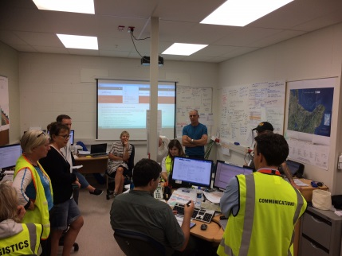
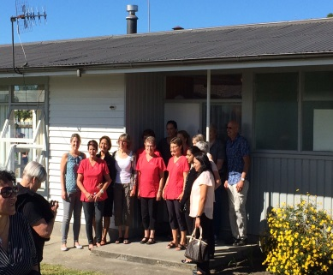

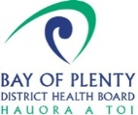

Version 5 March 2018

“Psychosocial recovery is not about returning to normality. It is about positively adapting to a changing reality. Recovery may last for an indeterminate period, from weeks to decades”
(Ref; Framework for Psychosocial Support in Emergencies MoH December 2015)

Introduction
This plan outlines the psychosocial recovery activities that bring together the skills, resources and available services to assist those individuals, families, neighbourhoods, and communities in the Eastern Bay of Plenty affected by significant flooding following Cyclones Debbie and Cook on the 6th April and 12th April 2017.
This Plan has been developed by the District Health Board Recovery Team, in collaboration with health providers of psychosocial support services, support agencies, and the Whakatane District Council Recovery Team. (See appendix 1).
It puts into operation the Bay of Plenty District Health Board Psychosocial Support Plan November 2016 through identifying work streams and associated actions.
Summary of flooding impact on the community
Ex-Cyclone Debbie and Cook resulted in significant regional flooding, a stop bank breached at Edgecumbe, slips caused road closures and isolation for communities at Ruatahuna, Te Mahoe, Ruatoki, and Te Whatai.
More than 1,600 residents were displaced from Edgecumbe and others from Taneatua, Poroporo and the plains area. 17 homes in Edgecumbe were red stickered, 240 yellow stickered (plus 12 in Taneatua and Poroporo) and 233 in Edgecumbe (plus 6 in the wider district) were white stickered. Services including power, water and wastewater were also disrupted.
Many people have experienced, and continue to experience stress, anxiety and grief as a consequence.
Immediate Psychosocial Response
The DHB activated its psychosocial plan, providing support to the Whakatane District Council Emergency Operations Centre and staff trained in Psychological First Aid to support displaced people at the Civil Defence Centres and Community Response Centres. The DHB also supported requests for Psychological First Aid training.
The shift from response to recovery resulted in the DHB reassessing medium and long term resourcing and support requirements.
This plan outlines how the DHB with its support partners intends to support psychosocial recovery activity for the next 6 months.

What is psychosocial support?
Psychosocial support is the process of meeting a person’s emotional, social, mental and spiritual needs. It is a non-therapeutic intervention that helps a person to cope with stressors. Psychosocial supports people capacity to understand and cope with adverse events. Appropriate psychosocial support helps people overcome these challenges, and builds coping mechanisms, trust and hope for the future. Families and communities are best placed to provide psychosocial support for each other, and therefore, interventions should work through the family to support affected individuals, families and communities.
Specialised psychological and social services play a key role.
Psychosocial support is embodied in the Te Whare Tapa Wha model of service delivery. The model describes the four corners (Hinengaro, Wairua, Tinana, Whānau) of the whare (house).
- Hinengaro support – mental and emotional wellbeing
- Wairua support – cultural and spiritual wellbeing
- Tinana support – physical/practical/financial wellbeing
- Whānau support – advocacy and extended family wellbeing

Key points/messages
- Affected people are usually best cared for in and by their own community
- Psychosocial support should not be a stand-alone intervention. There needs to be a longer-term, integrated approach to the needs of affected individuals and families
- Community level support needs to be supplemented by government service providers and by supportive government policies.

Psychosocial effects
The psychosocial effect of adverse events and the level of support required will vary depending on a range of risk factors and vulnerability.
Psychosocial support builds the intervention model of
- Basic services and security
- Community and family supports
- Focused, non-specialised supports
- Specialised services

Response and Recovery Streams
The following outlines the wide range of emotions that may be experienced in the days, weeks, months and years following a disaster.

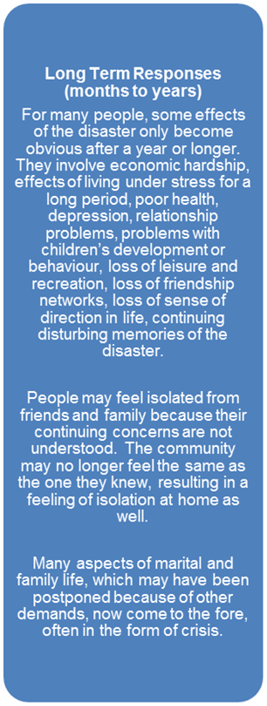
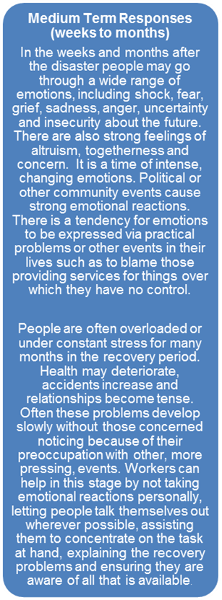
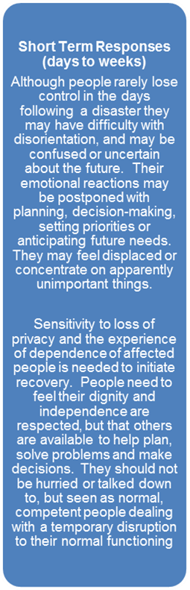
and

Initial Recovery Plan
The DHB implemented the following resource and structure to support the ongoing recovery efforts.
Executive Sponsor
Recovery Manager
Psychosocial Lead
External Health Providers Lead
Tangatawhenua Representative
Communications
Public Health
Lead

Under this operating model the DHB has identified following roles.
- Recovery Manager – initially for 6 months this role has responsibility for the management and oversight of the recovery effort and the team and resources mentioned in the structure.
- Executive Sponsor – this role supports the Recovery Manager and assists with escalation, resource allocation, risk management and links directly to the CEO and Board. The role is filled by Executive members on a monthly rotation.
- External Health Providers Lead – key functions include attending WDC Recovery team briefings, supporting the development and delivery of key actions and activities. The role supports the Recovery Manager and other Recovery Roles.
- Psychosocial Coordinator, - this role is responsible for fostering relationships with support agencies and organisations and working in collaboration with the Whakatane District Recovery office. The role draws from existing DHB staff and teams.
- Communications - the existing communication team will develop communication collateral for a variety of forums (social media/web/print) consistent with our objective to ensuring that people have easy access to psychosocial related key messages.

Goal: To restore and create opportunities to enhance community wellbeing working alongside Tangatawhenua
Overall Objectives:
- To coordinate psychosocial and social interventions to support recovery
- To ease the physical, psychosocial and social difficulties for individuals, families/whanau and communities
- To ensure other aspects of the recovery process do not result in further harm.

Key Performance Indicators
- Essential health and psychosocial needs of flood affected people are addressed. (Numbers of health & social issues followed up on.)
- Vulnerable people and groups are identified and key initiatives developed to address their needs (List of initiatives for people/ groups)
- People have ease of access to health services and self-help information. (Numbers of people accessing health line. Free GP visits, the Hub.)
- Number of community events supported to assist people to engage with services and other residents. (Numbers and types of events supported)
- Communication between providers of psychosocial is maintained and services are coordinated (number of meetings participated in, number of providers participating in meetings).
- Psychological First Aid Training is made available for providers (number of people trained & organisations engaging in training)
- Self-help resources specific to the event are developed. (number of resources developed)
- BOPDHB Psychosocial Recovery Plan updated to include learning from the psychosocial recovery activities and additional resources as appendices

Work Stream and Actions
Key √ Completed → Positive progress is underway × Not completed
Work Stream | Need/Strategies | Evidence | Key Tasks and Activities | Status | Progress
Adapting Positively to a Changed Reality  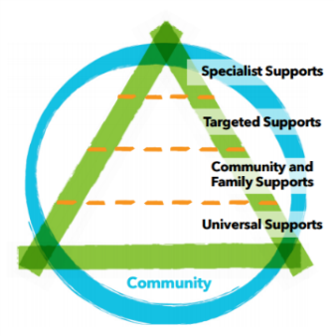 | Identify the psychosocial needs of the affected community/ responders and  support community led initiatives to meet the needs | Social ecology is a core domain of psychosocial support following an emergency.  Support through relationships social networks and existing support systems of people in their communities is essential.  Community events strengthen and enable communities through social connectedness.  Improve the capacity of people to cope, adapt, and move forward with their lives and encourage communities to lead and shape their own recovery. | - Provide a range of short term interventions which facilitate access to information and services including but not limited to:  - Free GP & pharmacy scripts established for patients of Riverslea Medical Centre.  - Additional Social Workers and programmes at schools  - Psychosocial information being sent home with school students re helping Rangitahi during the difficult times.  - Health & wellness services (delivered by Ngati Awa Social & Health Services NASH) at the hub.  - Home visits (NASH)  - Support Recovery Expos  - Apply for funding/provide a local anger management course for men  - Work with the NASH, Voyagers, MoE and local schools to assess ongoing needs of students.  - Support the WDC Recovery Team community gatherings for people returning to their homes  - Continue to identify opportunities to connect with the community. | √  √  √  √  √  √  →  √  →  → | In place through till 20th April 2017  Free flu vaccination for flood affected offered by Riverslea, recall and opportunistic vaccination underway  Social workers feeding back to the recovery team at hub meetings  First Expo 10/06/17  Steering group set up. Research undertaken re type of programme. Men’s forum established. Details distributed to teams and stakeholders  Schools supported with resilience programmes for sutuents  Needs fed back at the hub meetings, now fortnightly
Targeted Support | Identify the psychosocial needs of the affected community/responders and support community led initiatives to meet the needs.  Acknowledge community and providers for their support and success | International research suggests that severe disaster events tend to increase any existing inequalities.  This means that certain population groups may be more likely to need support and services.  Strengthen professional services for vulnerable populations  All those involved in the emergency are likely to benefit from some form of psychosocial support.  Community events strengthen and enable communities through social connectedness | - Examine local demographics, assess risk and vulnerable communities and the need for targeted support eg  - People whose dwellings were red, yellow or white stickered.  - In partnership with support agencies , identify vulnerable groups and enable appropriate supports to be put in place to respond when needed including:  - people who are isolated  - people with existing health or disabilities  - people who are displaced from their homes  - youth  - children  - Maori  - elderly  - unemployed beneficiaries  - parents with young children  - local business owners  - farmers and lifestyle block owners  - Support local wellness programmes/ activities arranged by the WDC activities Coordinator, Rural Support Trust & community.  - Arrange for additional psychological first aid training for health providers and the recovery team  - Investigate & develop intervention strategies to respond to the identified need for volunteers re self-help, wellness and ongoing volunteering  - Arrange celebrations for those who have participated in the response. | →  →  √  →  →  →  √  √ | Ongoing work in collaboration with WDC  Local Iwi providers redeployed staff to provide ongoing advocacy services to support individuals and whanau.  DHB psychologist worked with chamber of commerce to provide a session for business people in August  Plunket providing a fortnightly 2 hour mothers support group is. ongoing, with te reo and pamper sessions offered.  DHB Psychologist worked with Rural Support Trust to be available at one of the support group gatherings, positive feedback received.  PFA training provided 22nd May, 14th & 15th June, 27th July Total number 76  1st volunteer training provided by DHB psychologist 25th July 16 people positive feedback. 2 month follow-up session was offered but not required.  2nd session 9 people and 3rd 4 in the evening.  Morning tea provided for stakeholders and hub participants
Stakeholder Engagement | Work with the WDC recovery team and support agencies to ensure that psychosocial recovery activities continue to be community appropriate, collaborative, co-ordinated, supported and issues can be identified and addressed. | Iwi are a voice and a critical support for their people. They are able to provide services in a community they are familiar with and have access to.  Most people affected by the flooding will experience some levels of distress.  For many the distress they experience can be eased through care of friends, family/whanau, and communities. | - Engage tangatawhenua.  - Convene the EBOP subgroup with support partners to establish capacity, coordinate services, anticipate issues and support requirements  - Maintain monthly meetings of the EBOP subgroup so they are supported and any issues addressed  - Work with psychosocial health providers including (NASH, DHB Community Mental Health & Voyagers DHB Perinatal, infant, child & adolescent services) to ensure services are coordinated and gaps identified.  - Facilitate weekly info sharing meetings from representatives at the hub and follow-up on issues raised.  - Participate in the WDC Recovery Team Community partners Weekly Review meetings and follow-up in issues raised.  - Ensure ease of access to health services.  - Support local wellness programmes and activities arranged by the recovery activities coordinator, Rural Support Trust and the community | →  √  →  →  →  →  →  → | Ongoing contact and monthly meetings undertaken until October.  Meetings now held on an as required basis. Issues & information fed back to the DHB recovery team. Meetings held when required. Minutes circulated and actions addressed  Meetings now fortnightly, issues raised with recovery team  Follow up on issues raised with services, eg wait times for services  Follow up on issues raised by navigators and services at the hub  Resources and speakers provided for programmes where required
Resourcing | Scale resources up and down in order to meet the health and psychosocial needs of the affected communities  Ensure that the DHB psychosocial recovery response is sustainable | An increase in resources and capacity is required to allow local providers to meet increased need.  There is also compounded stressors affecting already vulnerable families who require support resulting from the flooding | - Put in place the DHB recovery Structure as the responsible agency for coordination of psychosocial Recovery (NCDEM Plan 2015)  - Investigate the need for appointing navigators to provide wrap around services with key stakeholders  - Communicate information from weekly meetings to the DHB Recovery Team and relevant organisations/agencies to advocate for additional services.  - Monitor and assess visitors at the hub health and wellness services to ensure needs are being met.  - Monitor flood related calls to the health line 0800 number  - Liaise with health providers re capacity and flood related psychosocial issues  - Monitor and report capacity and issues relating to service delivery to DHB Management. | √  √  →  →  √  √  → | Response structure still in place  Navigators employed and DHB part of the  Governance Group. A navigator attends the hub meetings  Ongoing  Ongoing  Issues followed up with GPs via EBPHA
Psychosocial Collateral | Develop appropriate resources for distribution to the affected community to support psychosocial self-help and recovery | Affected communities should be able to easily access psychosocial related information and services through a range of traditional and non-traditional channels eg laundromat, hairdressers | - Develop a communication plan that supports the WDC communication plan  - Identify key messages  - Review and develop self-help resources appropriate to the affected community – fact sheets etc for media/websites/social media/networks/newsletter  - Ensure easy access to psychosocial related information to affected individuals, whanau and communities  - Coordinate public information messages with WDC and between key agencies | →  →  √  √  √ | Information sent to Communication team for development of the coms plan.  Request to Coms for new resources to be developed for EBOP  New resources sent to WDC for the newsletter. “Common Reactions, Helping Children, Helping Adolescents.”  Contact numbers on WDC recovery website. Wallet cards including transport and navigator support numbers  Ongoing
Information Management  Monitoring and Reporting | Establish appropriate data management system to monitor and report on key performance indicators  Maintain regular communication and reporting lines  Monitor the effectiveness of the psychosocial recovery response & develop an exit strategy |  | - Identify measures of success  - Set up data management system that tracks performance KPI.  - Provide regular reports to WDC on psychosocial actions  - Continue reporting DHB progress on Health EMIS.  - Report to DHB Executive via the Recovery Executive Liaison | √  √  √  → | KPIs developed,  EMIS log initially, now information provided in a monthly activity report  Report developed  and e-mailed to Executive Liaison for distribution. Information included in EP monthly report.  Lessons learned re psychosocial recovery presented to a National Mental Health Conference, the Tauranga Hospital Grand Round, the EBOP and WBOP Health Provider Emergency Response Key Stakeholder Groups. Very positive feedback has been received at all forums
Evaluation | Evaluate the psychosocial recovery response including the short and long term interventions |  | - Develop an evaluation programme including milestones evaluation  - Provide opportunity for health providers to review their response regarding what worked well, what needs to change & recommendations.  - Develop & conduct a survey of consumers and report on results including recommendations and action plan  - Update the DHB Psychosocial Recovery plan. | X  →  X  X | This is ongoing via stakeholder meetings
References: BOP DHB Psychosocial Support Plan November 2016
Draft WDC Flood Recovery Action Plan 2017
Framework for Psychosocial Support in Emergencies MoH 2016
Kaikoura District Social Recovery Plan (V4) Kaikoura District Council Nov 2016)

Authors: BOP DHB Recovery Team; Karen Smith, Sue Mackersey, Martin Chadwick & Jocelyn Stowers,

Date: June 2017

Appendices:

- Psychosocial Recovery Stakeholders
- Media plan
- Evaluation programme
- Exit Strategy

Appendix 1: EBOP Flooding April 2017 Psychosocial Support Agency Role & Resource Information
Organisation | Existing psychosocial service provided | Additional support for the response | Contact Numbers | Other networks resources strengths
Ngati Awa Social & Health Service | Health & Social Services in EBOP | - Social Workers in schools  - Alcohol & drug social workers  - Nurse practitioners providing community nurse outreach programme  - Family Start Services  - Support for the Te Tari Awhina Hub drop in service | Enid Ratahi-Pryor  enid@nash.org.nz  07 307 1472 | Networks with health and social services within the EBOP
DHB Community Mental Health Services | Needs assessment and counselling and MH Nursing services  Older peoples service  MH crisis services  Rehab programmes | - Counselling services  - Groups – training to support volunteers  - Men’s groups – relationships, anger management, self help | Kim Hansen  Kim.Hansen@bopdhb.govt.nz  027 273 3207 | Networks with health and social services within the EBOP
Eastern Bay Primary Health Alliance | Community mental health services  Counselling, primary health (Physical health) | - Counselling support  - Mental health assessments  - Facilitating group/peer support  - First response for existing clients | Jeanie Rossiter  07 306 2303 | Affiliated Hauora providers at hapu/iwi level
Salvation Army | - Counselling and social work services / pastoral care  - Foodbank  - Positive lifestyle programmes | - Door knocking teams  - Flying squad with counselling  - PFA and social clients support  - Call on trained staff nationally/  internationally  - Premises for CD centre | Office: 07 308 6923  Phil: 027 5046262  John: 07 308 0694 | Pastoral care
Rural Support Trust | Support for the rural community. | - Outreach rural needs assessment  - Provision of advice and support  - Rural events to connect communities  - Referral to other agencies | Igor Gerritsen  027 357 8010  igorgerritsen@gmail.com
Red Cross | PS support to those affected as required | - Door knocking teams PS trained and police checked  - PS trainers / staff nationally available  PS support available from AUSRC and RCRC | duty@redcross.org.nz  Duty Mng  027 801 9661  DMO  027 2313457
Work and Income | - Income support  Data relating to vulnerable clients those who cannot work and on supported living benefits. | - Food, clothing  - Grants  - Furniture  - Staff, approx. 150  - $$ counselling, medication  - Large buildings/office space  Fleet of vehicles | Whka: Sheneen Stevenson  07 922 6319  Sheneen.stevenson018@msd.govt.nz  Kawerau – Bobby Nyman  07 922 6099  Opotiki – Bev Norton  - 07 922 9401 | - Buildings  - Vehicles  - Funding for meds/counselling  - Lots of staff

Ministry of Education | Support schools and school communities | - Deploy traumatic incident teams as necessary | Margaret Gardiner  margaret.gardiner@education.govt.nz  Anna Hayward  027 504 6229  anna.hayward@education.govt.nz
Tuhoe Hauora | Child, adolescent & youth alcohol & drug community services.  Infant, child adolescent & youth CMH services | - Contact and support for whanau  - Marae accommodation for displaced whanau  - Health & social service  - Financial support for whanau in need | Pricilla Woods  07 312 9874  Pricillaw@tuhoehauora.org.nz
Te Puna Ora O Mataatua | Home based support services  Kiatoko Whanau Service  Mama & Pepi Service | - Contact and support for whanau  - Marae accommodation for displaced whanau  - Health & social service | Maria Clarke  hbsmgr@tpoom.co.nz  07 308 0580  027 507 8774
Pou Whakaaro | Peer support for people with MH or addiction  Support advocacy and info to families of people who suffer from Mental illness or addiction | - Additional peer support for people with MH or addiction  - Support advocacy and info to families of people who suffer from Mental illness or addiction  - Storage of donated goods  - Volunteers to support people | Claire Pye  Yvonne McGarvey  07 308 8170
Disabilities Resource Centre Trust | Home care community services and advocacy/information for people with disabilities and older people | - Contact and additional support for people  - Information on where to go for help | Noel Bentlan  07 307 1447  drct@drct.co.nz
Tuwharetoa ki Kawerau Hauora Trust | Health social and education services  Tamariki Ora  Family Start programme  Whanau Ora  High needs service coord  MH services | - Marae accommodation for displaced people  - First aid & support for people  - Mental Health teams support for people including trauma support  - Support with temporary housing  - Additional Nursing services to support affected people | Peta Ruha  Peta@tuwharetoa.org.nz  07 323 8035
Healthcare NZ | Home based support services, personal care, restorative care, long term condition management nursing services integration support | - Contact and support clients  - Support additional clients affected by the event | Ann Lewis  Ann.lewis@healthcarenz.co.nz  Sue Baker
Whakatohea Maori Trust Board | Primary care and medical Services  MH services  Tamariki Ora services  Alcohol & Drug services  Living without violence  Whanau care & support | - Primary care and medical Services  - MH services  - Tamariki Ora services  - Alcohol & Drug services  - Living without violence  - Whanau care & support  - Advice and advocacy | Louise Erickson  louise.erickson@whakatohea.co.nz  07 315 8500
WDC Recovery Team | Information and support  Need assessment | - Needs assessment  - Events coordinator  - Facilities for community hub  - Situational information  - Coordination of the welfare response  - Access to the mayoral fund | Paula Chapman  021 233 3970  Barbara Dempsey  027 705 4775  Chris King-Hazel  027 440 0219  Meagan Edhouse  0277241 969

MSD CYF | Social Work  Support for vulnerable children/caregivers | - BOP team evidential forensic interviews.  - BOP psychologist  - Identifying and providing support (SWs) for children in need of care and protection of CYFs  - Identifying Maori children and liaising with Te Pune Kokiri  - Providing support to children and young people in care.  - Police vetting possible caregivers  - Police vetting of workers in CD centres, providing oversite at CD centres  - Referral to other agencies  - Support from other CYF sites  - Fleet of vehicles | Care & Protection Coordinator  Gillian Robertson  07 928 5173 / 029 650 0288  Gillian.robertson016@cyf.govt.nz  Tayelva Petley (BOP Ops Mng CYF)  029 6500035  Tayelva.petley002@cyf.govt.nz
MSD |  |  | Dominic Lepa  029 200 3439  Brent McDonald
New Zealand Association of Counsellors | Counselling Services | Counselling Services | Sandra Gee  07 315 8578, 0212494327  evolvesandra@xtra.co.nz
Plunket |  |  | Hepina Bolin  hepina.bowlin@plunket.org.nz  Natalie Brierley  natalie.brierley@plunket.org.nz
Te Puni Kokiri | Connecting with key Māori communities and organisations | - Advice and support to connect with key people in Māori communities  - Provide cultural support for door to door assessments and in CD centres  - Provide info and advice on psychosocial support  - Connect whanau, hapu, iwi to psychosocial support | Regional Manager Rachel Jones:  07 577 6254  027 201 8555  Shaneen:  027 4440821 | - Staff/vehicles  - marae – beds/food  - land trusts – machinery/access to land  Incorporations – as above
Victim Support | Support victims who have been subject to crime and trauma | - Contact with MSD to get funding to send people for counselling  - Provide support workers for door to door assessments. Staff are told to look after themselves and family and then report to work  - Will call workers from other regions  - National crisis line 24/7 | Lydia Allan 027 241 1590  Anna Meredith 027 498 4080  0800 842 846 24/7 | - Emotional support/PFA  - Advocacy, needs assessment  - Clear knowledge and understanding of local agencies for others’ support  - Ability to provide support remotely and long term

